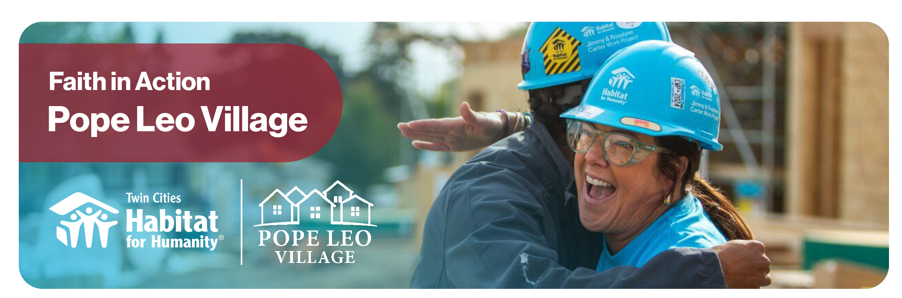

Building homes, community, and hope
[School/Faith Community] is proud to partner with Twin Cities Habitat for Humanity in support of Faith in Action: Pope Leo Village, a national interfaith movement building five affordable homes at The Heights development in St. Paul, as well as other homes across the metro.

3 ways to participate
Volunteer: Lend a hand on a construction site (at The Heights or other build site), or volunteer at ReStore home improvement outlets, where every purchase and donation supports Twin Cities Habitat for Humanity’s mission. You can also bake cookies for volunteers or make welcome signs for homeowners.
Give: Donate directly to help fund five affordable housing in the Twin Cities.
Fundraise: Create a peer-to-peer fundraising page and mobilize your network.

Our [school/faith community] is supporting Pope Leo Village by:
$X,XXX Fundraising Goal
To donate, scan the QR code below to visit our fundraising page:
[Insert your peer-to-peer fundraising link]
XXX-hr/XXX Person
Volunteering Goal

To get learn more, visit tchabitat.org/popeleovillage
and contact [Coordinator name, coordinator job title] to get involved.
coordinator.email@email.com | 123-456-7890
All gifts are tax-deductible as allowed by law, and support Twin Cities Habitat for Humanity.

The Pope Leo Village brings together people of all faiths and backgrounds to create affordable housing and lasting community. Every gift and every hour of service make a difference.
“In that service to others we may find that coming together in friendship,
building up community, we too can find true meaning in our lives.”
- Pope Leo XIV

